Victor Udeh  
CS210  
Title: Grocery-Tracking Program Documentation  
Oct 11, 2023

Introduction:  
The Grocery-Tracking Program provides a utility for the Corner Grocer to analyze text records generated throughout the day. These records list items purchased, and the aim is to determine the frequency of each item.

Design & Implementation:

1. Class Design:  
   The core of the application is structured around the **GroceryTracker** class. This class encapsulates the data and operations related to the grocery items and their frequencies.
   * Private Data Member:
     + **itemsFrequency**: A map that stores grocery items (as strings) and their respective purchase frequencies (as integers).
   * Private Method:
     + **readFromFile**: Reads items from a given file and populates the **itemsFrequency** map. It also backs up this data to **frequency.dat**.
   * Public Methods:
     + **findSpecificItem**: Prompts the user for an item and displays its purchase frequency.
     + **displayAllItems**: Displays the frequency of all recorded items.
     + **displayHistogram**: Presents a histogram where each item's frequency is visualized using asterisks.
2. Main Function:  
   The **main** function serves as the user interface of the program. It provides a menu-driven system where the user can:
   * Search for a specific item's frequency.
   * View frequencies of all items.
   * View a histogram representation.
   * Exit the program.

Functionality:  
Upon execution, the program reads item data from the provided **CS210_Project_Three_Input_File.txt** file. It then offers the user four main functionalities:

* Search for Specific Item Frequency: When selected, this option prompts the user to input a grocery item's name. The program then displays how many times this item was purchased.
* Display Frequency of All Items: This option lists all grocery items along with their purchase counts.
* Display Histogram: Provides a visual representation of item frequencies. Each item's frequency is shown using asterisks, with one asterisk corresponding to one purchase.
* Exit: Gracefully closes the program.

Screenshots:  
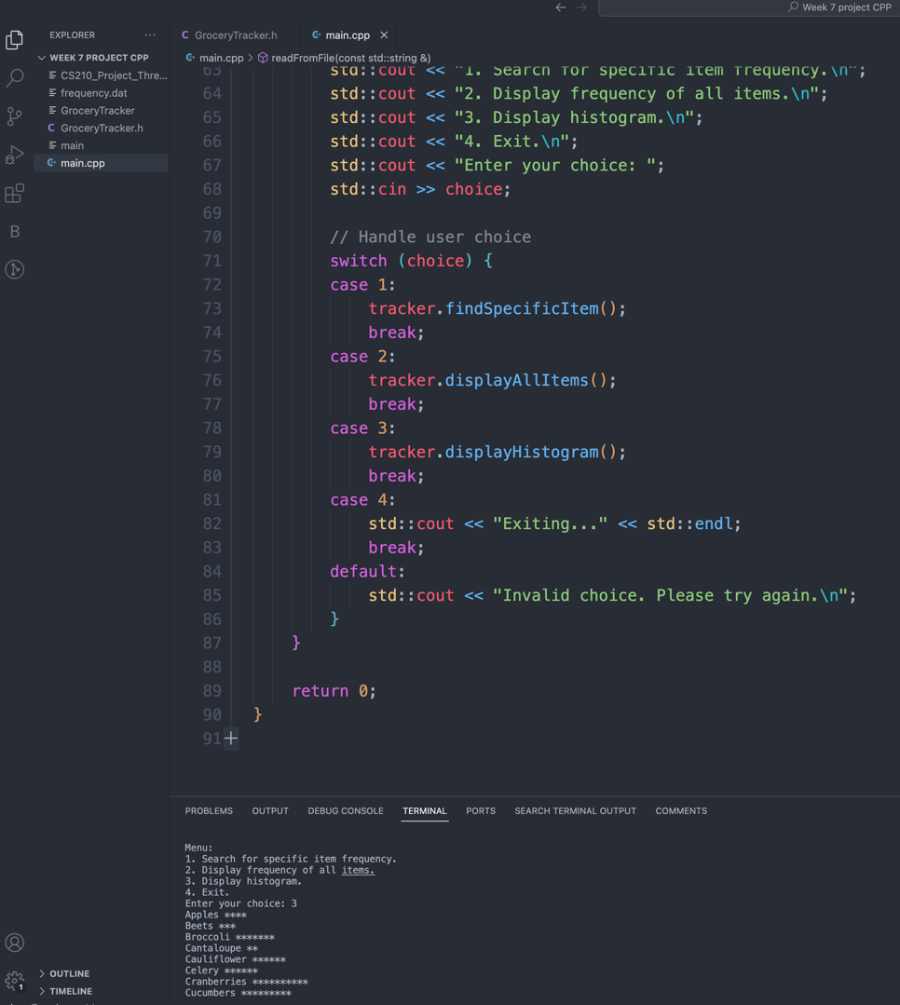

Conclusion: The Grocery-Tracking Program effectively assists the Corner Grocer in analyzing daily purchase records. With its intuitive menu-driven interface, the store can easily gather insights about item popularity, aiding in making informed decisions about store layout and stock management.